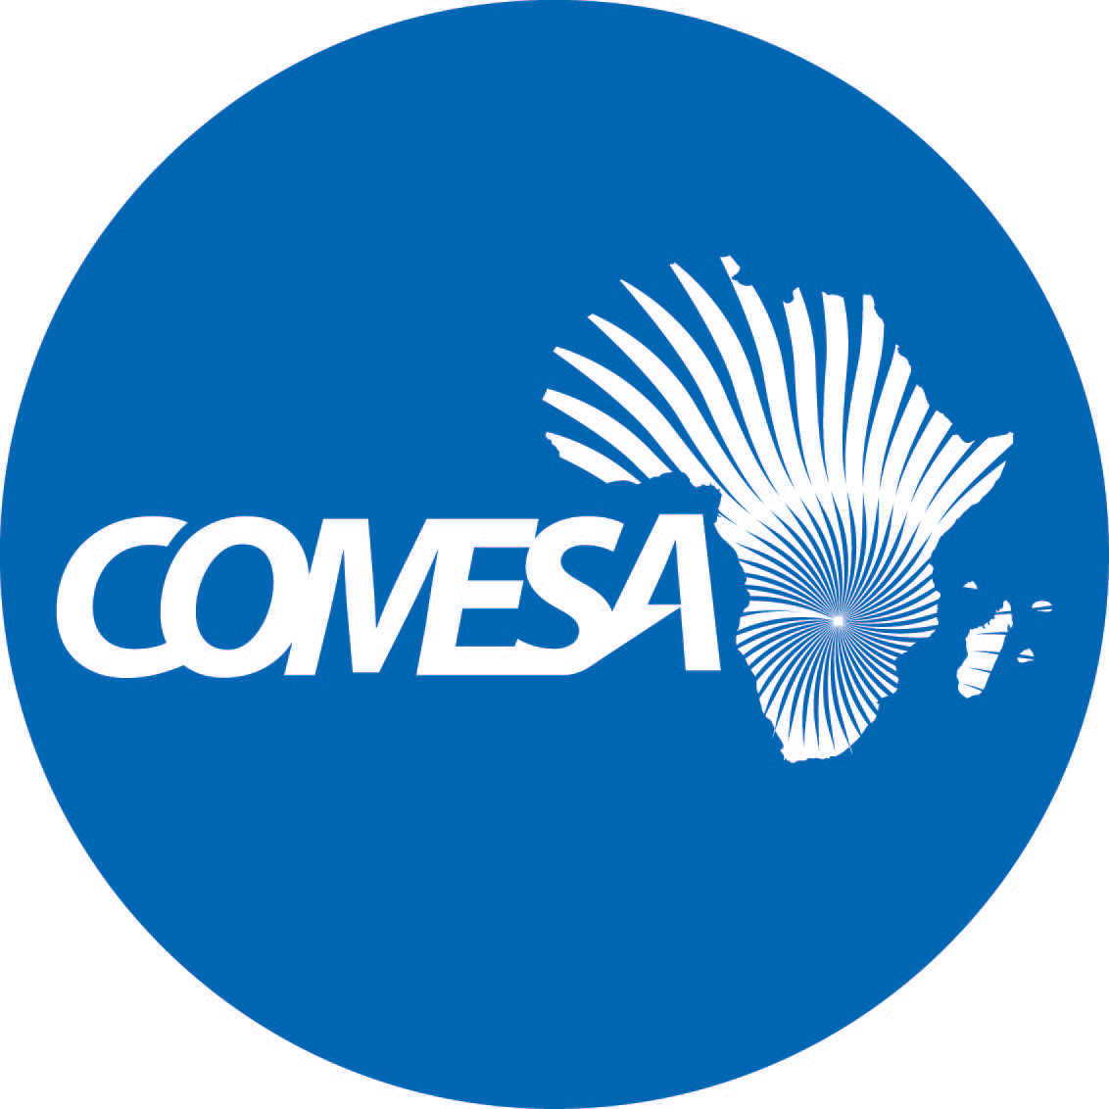

Distr.
LIMITED

CS/CMI/MERP/XVII
October 2023

Original: ENGLISH

COMMON MARKET FOR EASTERN
AND SOUTHERN AFRICA

20th Meeting of the COMESA Monetary and Exchange Rates Policies Sub-Committee

October 05-06, 2023

NAIROBI KENYA

REPORT OF THE ACHIEVEMENT OF MACROECONOMIC CONVERGENCE BY COMESA MEMBER COUNTRIES IN 2022

2023 (LN/TB-joo-fwn)

Report on the progress towards achievement of macroeconomic convergence by COMESA member countries in 2022 (Agenda Item 3)

- The assessment of achievement of macroeconomic convergence criteria in 2022 is based on the revised COMESA macroeconomic convergence criteria (2019-2025), summarized as follow:

Primary Criteria

- Overall budget deficit/GDP ratio (including grants) of not more than 5%
- Annual average inflation rate of 7% (with a band of +/-1%).
- Central Bank financing of the budget deficit/average revenue of last 3 financial years of not more than 5% (target of 0%)
- External Reserves of equal to or more than 3 months of imports cover (target is atleast 6 months)

Secondary Criteria

- Nominal Exchange rate Variability against the US Dollar of ±10%
- Central Government Debt Stock as a ratio of GDP at less than 65%
- Total Tax Revenue to GDP Ratio of atleast 20%.
- Achievement and maintenance of Government Capital Investment to Tax Revenue of at least 20%

- Table 1 gives a summary of the progress made towards achieving macroeconomic convergence by member states in 2022.

Table 1: 2022 Macro-Economic Convergence Achievements
Country | Primary Criteria |  |  |  | Secondary Criteria
Country | 1  (% of GDP) | 2  (%) | 3  (%) | 4  (Months) | 1  (%) | 2  (% of GDP) | 3  (% of GDP) | 4  (% of Tax Rev)
Burundi | -5.0 | 18.9 | 17 | 1,8 | 2.95 | 57.9 | 13.4 | 51.4
Burundi | Met | Not Met | Not Met | Not Met | Met | Met | Not Met | Met
Congo. Dem. Rep. | -1.7 | 9.3 | 0 | 2.6 | -0.8 | 15.5 | 11.8 | 10.0
Congo. Dem. Rep. | Met | Not Met | Met | Not Met | Met | Met | Not Met | Not Met
Comoros | -1.7 | 12,4 | 18.7 | 7.6 | -10.97 | 31.6 | 7.1 | 18.6
Comoros | Met | Not Met | Not Met | Met | Not Met | Met | Not Met | Not Met
Djibouti | -1.4 | 5.2 | 0 | 5.1 | 0 | 66.8 | 11.6 | 21.3
Djibouti | Met | Met | Met | Met | Met | Not Met | Not Met | Met
Egypt Arab Rep | -6.1 | 8.5 | N/A | 3.9 | -4.5 | N/A | 12.5 | 32.1
Egypt Arab Rep | Not Met | Not Met |  | Met | Met |  | Not Met | Met
Eritrea | -1.3 | 7.4 | N/A | 4.5 | N/A | 163.8 | N/A | N/A
Eritrea | Met | Not Met |  | Met |  | Not Met
Ethiopia | -4.2 | 33.9 | N/A | 0.7 | N/A | 46.4 | N/A | N/A
Ethiopia | Met | Not met |  | Not met |  | Met
Eswatini | -5.5 | 4.8 | 17.6 | 2,6 | -10.3 | 37.2 | 25.1 | 23.7
Eswatini | Not Met | Met | Not Met | Not Met | Not Met | Met | Met | Met
Kenya | -6.2 | 7.7 | 3.7 | 3.7 | 7.4 | 66.9 | 13.8 | 29.2
Kenya | Not Met | Not Met | Met | Met | Met | Not Met | Not Met | Met
Madagascar | -4.5 | 8.2 | 4.7 | 4.3 | 7.0 | 38.3 | 11.2 | 52.8
Madagascar | Met | Not Met | Met | Met | Met | Met | Not Met | Met
Libya | 0.0 | 4.6 | 0.0 | 38.5 | -5.2 | 57.9 | 0.5 | 2410
Libya | Met | Met | Met | Met | Met | Met | Not Met | Met
Malawi | -10.5 | 20.9 | 11.0 | 2.8 | 26.3 | 68.2 | 13.3 | 61.3
Malawi | Not Met | Not met | Not met | Not Met | Not Met | Not Met | Not Met | Met
Mauritius | 3.9 | 10.8 | 17.7 | 11.6 | -1.1 | 75.8 | 21.6 | 15.5
Mauritius | Met | Not Met | Not Met | Met | Met | Not Met | Met | Not Met
Rwanda | -7.3 | 13.9 | 0 | 4.2 | 4.2 | 67.5 | 15.3 | 66.3
Rwanda | Not Met | Not Met | Met | Met | Met | Not Met | Not Met | Met
Seychelles | -1.6 | 2.6 | 0.0 | 3.4 | 16 | 69.2 | 33.3 | 10
Seychelles | Met | Met | Met | Met | Not Met | Not Met | Met | Not Met
Somalia | 0 | 6.8 | N/A | N/A | N/A | N/A | N/A | N/A
Somalia | Met | Met
Sudan | -2.1 | 138.8 | N/A | 2.3 |  | 127.6 | N/A | N/A
Sudan | Met | Not Met |  | Not Met |  | Not Met
Tunisia | -6.6 | 8.3 | N/A | 3.4 | N/A | 79.4 | N/A | N/A
Tunisia | Not Met | Not Met |  | Met |  | Not Met
Uganda | -7.4 | 3.4 | 18.4 | 4.4 | -2.4 | 48.4 | 12.5 | 40.0
Uganda | Not Met | Met | Not Met | Met | Met | Met | Not Met | Met
Zambia | -7.81 | 11.1 | 0 | 3.8 | -15.5 | 88.3 | 15.8 | 22.9
Zambia | Not Met | Not Met | Met | Met | Not Met | Not Met | Not Met | Met
Zimbabwe | -1.71 | 193.4 | 0.0 | 1.1 | 684.3 | 58.4 | 16.6 | 19.4
Zimbabwe | Met | Not Met | Met | Not met | Not Met | Met | Not Met | Not Met
Source: IMF REO Sub Saharan Africa April 2023; IMF REO Update Middle East and Central Asia
April 2023; and Country Reports for Burundi, Comoros, Djibouti, DRC, Egypt, Eswatini, Kenya, Libya, Madagascar, Malawi, Mauritius, Rwanda, Seychelles, Uganda, Zambia and Zimbabwe.

Notes: N/A outturn numbers were not available at the time of compiling this report.

- The progress related to Primary and Secondary macroeconomic convergence criteria by member countries in 2022 as summarized in Table 1 indicate the following:

PRIMARY CRITERIA

I. Overall budget deficit/GDP ratio (Including grants) of at most 5%

- The region’s average overall budget deficit including grants as a percentage of GDP started to decline from 5.4% in 2021 to 4.9% in 2022, with a projected consolidation of 3.9% in 2023. The improvement reflects a combination of higher tax revenues and fiscal adjustment as countries continue to consolidate their public finances to preserve fiscal sustainability (particularly those with elevated debt vulnerabilities) on the path to a credible and transparent medium-term fiscal policy framework.

- Thirteen (13) COMESA member countries namely Burundi, Congo DR, Comoros, Djibouti, Eritrea, Ethiopia, Libya, Madagascar, Mauritius, Seychelles, Somalia, Sudan and Zimbabwe achieved convergence Criteria of overall budget deficit/GDP ratio (including grants) of not more than 5%.

II. Annual average inflation rate of 7% (with a band of +/-1%)

- The COMESA region wide average inflation rate rose to 19.4% in 2022, up from 14.6% in 2021, which is more than double the pre-pandemic average of 9.4%. There was strong build-up of inflationary pressures in most COMESA countries, hitting double digit particularly in countries that have greater reliance on food imports or suffered he wrath of climate change (droughts, storms and floods) which amplified the effect of distortions in global supply chain and on a significant increase in international energy prices during the year under review. Furthermore, some countries yielded to significant pressures to raise public wages in response to increases in the cost of living triggered by higher food and fuel prices.

- Seven (07) COMESA member countries, namely Djibouti, Eswatini, Madagascar, Libya, Seychelles, Somalia and Uganda achieved the COMESA macroeconomic Convergence Criteria on average annual inflation rate of 7% (with a band of +/-1%).

III. Minimize the Central bank financing of the budget towards zero

- Most COMESA member countries have rules which prescribe Central Bank financing as a % of the previous year’s tax revenue. In the COMESA macroeconomic convergence criteria, it is capped at no more than 5% (target of 0%) of the budget deficit/average revenue of last 3 financial years. However, as the fiscal deficit continues to mount, public sector borrowing requirements, mainly from the domestic market increased substantially during the year under review. Hence, recourse to Central Bank resources was inevitable for a number of member countries that reported the data.

- Nine (09) out of the 16 COMESA member countries that reported data, namely Congo DR, Djibouti, Kenya, Madagascar, Libya, Rwanda, Seychelles, Zambia and Zimbabwe achieved the criteria on Central Bank financing of the budget deficit/average revenue of last 3 financial years of not more than 5%.

IV. External Reserves of equal to or more than 3 months of imports of goods and services

- Adequate reserves help countries better manage their economies and respond to external shocks, while appropriate reserve management is essential for minimizing the opportunity cost of holding reserves and maximizing returns.

- The COMESA region external reserve cover dwindled to an average of 2.5 in month of imports of goods and services, down from 3.1 months of import of good and services in 2021. The dip in external reserves in months of imports of goods and services during the year under review reflects considerable pressure to provide for foreign exchange to smooth disruptive volatility in the exchange rate and supporting oil and food imports particularly for commodity importing economies of the region.

- Thirteen (13) COMESA member countries namely, Comoros, Djibouti, Egypt, Eritrea, Kenya, Libya, Madagascar, Mauritius, Rwanda, Seychelles, Tunisia, Uganda and Zambia achieved the COMESA macroeconomic Convergence Criteria of External Reserves of equal to or more than 3 months of imports of goods and services.

- Overall, the assessment of COMESA Member States’ performance on the primary convergence scale during the year under review indicate that three member countries—Djibouti, Libya and Seychelles achieved all the four primary criteria. Each of the ten countries—Comoros, Eritrea, Kenya, Madagascar, Mauritius, Rwanda, Somalia, Uganda, Zambia and Zimbabwe met atleast 50 percent of the four primary criteria. Burundi, Congo DR, Egypt, Ethiopia, Eswatini, Sudan and Tunisia met one criteria. One member country breached all the four primary criteria.

- Annual average inflation rate of 7% (with a band of +/-1%) criteria was the most difficult criteria for Member States to attain, while External Reserves of equal to or more than 3 months of imports cover (target is atleast 6 months) was the most achieved.

- The performance score on the primary convergence scale for the region improved to 46%, compared to 40% and 44% attained in 2021 and 2020, respectively.

SECONDARY CONVERGENCE INDICATORS

I. Nominal Exchange rate Variability against the US Dollar of ±10%

- The tightening cycle in global financial conditions especially aggressive interest rate hike by the US Fed continued in 2022 in response to inflationary pressures triggered by overlapping crises. As a result, exchange rate pressures remained heightened and inflation stayed above the pre pandemic level, on average, in the region. At the same time, output levels remained depressed, and is projected to decline steadily for a second year in a row in 2023 at levels below the pre-pandemic level. The funding squeeze, on account of the challenging external financing conditions and climate change which is presenting additional spending pressures on shrinking fiscal budgets complicates the region’s macroeconomic environment even further.

- Striking a balance between containing the ongoing inflationary pressures and supporting the on-going economic recovery, while at the same time manage exchange rate volatilities in response to tightening global financial conditions remains a key challenge for the regional Central Banks. Even in the face of weak economic activity, many regional Central Banks have tightened monetary policy to anchor inflation expectations and allowed the exchange rate to depreciate while conducting foreign exchange interventions to smooth disruptive volatility. The depreciation of currencies in member countries had adverse impact on debt repayment obligations and inflation.

- Ten (10) out of the 16 COMESA member countries that reported data, namely Burundi, Congo DR, Djibouti, Egypt, Kenya, Libya, Madagascar, Mauritius, Rwanda, and Uganda achieved the revised COMESA secondary Convergence Indicator of nominal exchange rate variability of ±10%.

II. Central Government Debt Stock as a ratio of GDP at less than 65%

- The region’s average Government debt as a share of GDP increased, albeit marginally, to 57.6% in 2022, compared to 57.4% in 2021, reflecting a combination of still-large overall fiscal deficits because of overlapping crises, slower growth and the impact of exchange rate depreciations.

- Nine (09) COMESA member countries namely, Burundi, Congo DR, Comoros, Ethiopia, Eswatini, Libya, Madagascar, Uganda and Zimbabwe achieved the COMESA secondary Convergence Indicator of total government debt as a share of GDP of less than 65%.

III. Total Tax Revenue to GDP Ratio of at least 20%.

- Adequate level of revenue to GDP ratio is necessary to implement policies that would move the economies into virtuous cycle of higher investment and higher growth.

- Three (03) out of the 16 COMESA member countries that reported data, namely Eswatini, Mauritius, and Seychelles achieved the secondary Convergence indicator of total tax revenue to GDP ratio of at least 20%.

IV. Achievement and maintenance of Government Capital Investment to Tax Revenue of at least 20%

- Eleven (11) out of the 16 COMESA member countries that reported data, namely Burundi, Djibouti, Egypt, Eswatini, Kenya, Libya, Madagascar, Malawi, Rwanda, Uganda and Zambia achieved the secondary Convergence indicator of maintenance of government capital investment to tax revenue of at least 20%.

- Overall, the assessment of COMESA Member States’ performance on the secondary convergence scale during the year under review, among the countries that reported the data indicate that each of the five countries—Burundi, Eswatini, Libya, Mauritius, and Uganda met three of the four secondary criteria. Congo DR, Djibouti, Egypt, Kenya, and Rwanda met two of the secondary criteria each while Comoros, Ethiopia, Malawi, Seychelles, Zambia and Zimbabwe breached all except one criterion, each. Eritrea, Ethiopia, Somalia, Sudan and Tunisia did not submit the data.

- Among the countries that reported data, tax revenue to GDP ratio of at least 20% criteria remained the most difficult secondary criteria for Member States to attain, while achievement and maintenance of Government Capital Investment to Tax Revenue of at least 20% was the most achieved.

- The performance score on the secondary convergence scale for the region in 2022 improved to 35%, compared to 26% attained in 2021.

References

- IMF REO Sub Saharan Africa April 2023: IMF REO Update Middle East and Central Asia April 2023.
- AfDB African Economic Outlook 2023.
- AU, UNECA” Economic Report on Africa 2023.
- Country Reports for Comoros, Djibouti, DRC, Egypt, Eswatini, Kenya, Libya, Madagascar, Malawi, Mauritius, Rwanda, Seychelles, Uganda, and Zambia

.

