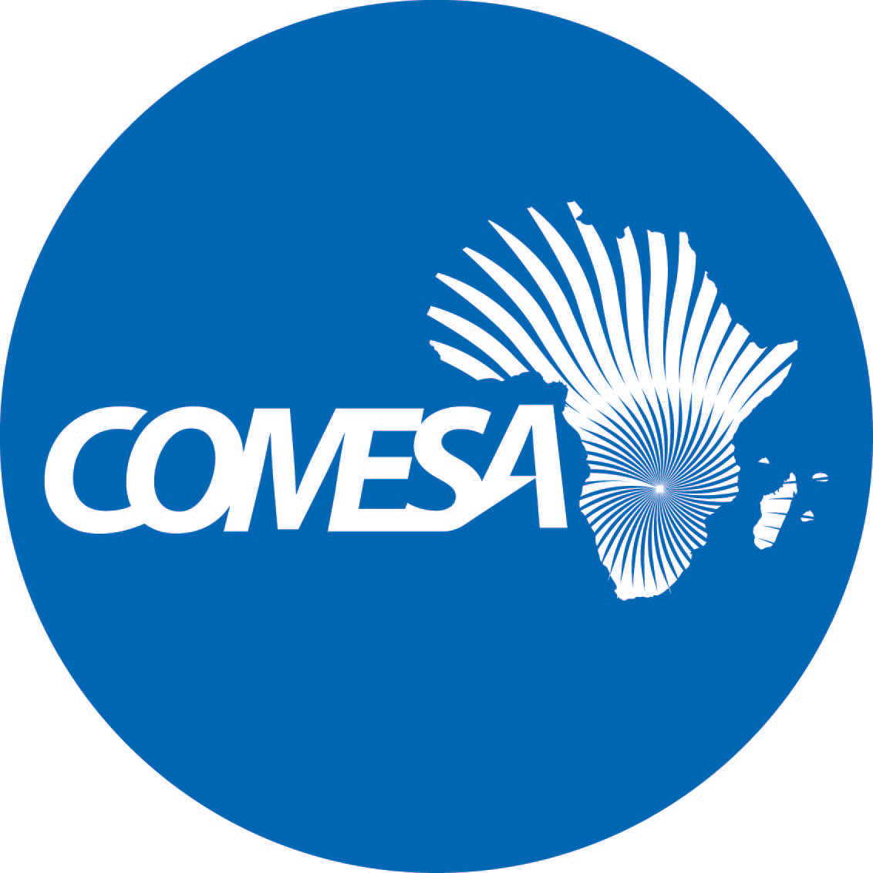

Distr.
LIMITED

CS/CMI/MERP/XVII
October 2022

Original: ENGLISH

COMMON MARKET FOR EASTERN
AND SOUTHERN AFRICA

19th Meeting of the COMESA Monetary and
Exchange Rates Policies Sub-Committee

October 2022

VIRTUAL

REPORT OF THE ACHIEVMENT OF MACROECONOMIC CONVERGENCE BY COMESA MEMBER COUNTRIES IN 2021

2022 (TB/joo)

Report on the progress towards achievement of macroeconomic convergence by COMESA member countries in 2021 (Agenda Item 3)

- The assessment of achievement of macroeconomic convergence criteria in 2021 is based on the revised COMESA macroeconomic convergence criteria (2019-2025), summarized as follow:

Primary Criteria

- Overall budget deficit/GDP ratio (including grants) of not more than 5%
- Annual average inflation rate of 7% (with a band of +/-1%).
- Central Bank financing of the budget deficit/average revenue of last 3 financial years of not more than 5% (target of 0%)
- External Reserves of equal to or more than 3 months of imports cover (target is atleast 6 months)

Secondary Criteria

- Nominal Exchange rate Variability against the US Dollar of ±10%
- Central Government Debt Stock as a ratio of GDP at less than 65%
- Total Tax Revenue to GDP Ratio of atleast 20%.
- Achievement and maintenance of Government Capital Investment to Tax Revenue of at least 20%

- Table 1 gives a summary of the progress made towards achieving macroeconomic convergence by member states in 2021.

Table 1: 2021 Macro-Economic Convergence Achievements
Country | Primary Criteria |  |  |  | Secondary Criteria
Country | 1  (% of GDP) | 2  (%) | 3  (%) | 4  (Months) | 1  (%) | 2  (% of GDP) | 3  (% of GDP) | 4  (% of Tax Rev)
Burundi | -2.9 | 8.3 | 0.7 | 3.2 | 3.2 | 55.9 | 14.4 | 49.8
Burundi | Met | Not Met | Met | Met | Met | Met | Not Met | Met
Congo. Dem. Rep. | 0.0 | 9.0 | N/A | 0.8 | N/A | 12.7 | N/A | N/A
Congo. Dem. Rep. | Met | Not Met |  | Not Met |  | Met
Comoros | -2.4 | 1.5 | N/A | 8.2 | N/A | 25.2 | N/A | N/A
Comoros | Met | Met |  | Met |  | Met
Djibouti | -2.1 | 0.2 | 0 | 4.9 | 0 | 74.8 | 18.9 | 40.1
Djibouti | Met | Met | Met | Met | Met | Not Met | Not Met | Met
Egypt Arab Rep | -7.4 | 4.5 | N/A | 6.0 | 2.2 | N/A | 13.0 | 29.9
Egypt Arab Rep | Not met | Met |  | Met | Met |  | Not Met | Met
Eritrea | -4.0 | 4.5 | N/A | 2.2 | N/A | 170.8 | N/A | N/A
Eritrea | Met | Met |  | Not met |  | Not Met
Ethiopia | -2.8 | 26.8 | N/A | 1.6 | N/A | 52.9 | N/A | N/A
Ethiopia | Met | Not met |  | Not met |  | Met
Eswatini | -6.4 | 3.7 | 16.7 | 3.4 | -10.3 | 39.0 | 24.6 | 21.5
Eswatini | Not Met | Met | Not Met | Met | Not Met | Met | Met | Met
Kenya | -8.2 | 6.1 | 4.2 | 5.4 | 3.0 | 66.2 | 13.1 | 36.9
Kenya | Not Met | Met | Met | Met | Met | Not Met | Not Met | Met
Madagascar | -3.0 | 5.8 | 0 | 5.8 | 3.4 | 36.2 | 10.1 | 50.6
Madagascar | Met | Met | Met | Met | Met | Met | Not Met | Met
Libya | -0.5 | 3.7 | N/A | N/A | N/A | N/A | N/A | N/A
Libya | Met | Met
Malawi | -8.4 | 9.3 | 28.5 | 1.7 | 5.9 | 59.0 | 9.7 | 53.5
Malawi | Not Met | Not met | Not met | Not Met | Met | Met | Not Met | Met
Mauritius | 5.0 | 6.8 | 16.5 | 17.6 | -8.5 | 87.2 | 21.6 | 21.7
Mauritius | Met | Met | Not Met | Met | Met | Not Met | Met | Met
Rwanda | -7.6 | 0.8 | 0 | 5.1 | 3.1 | 73.3 | 15.6 | 73.8
Rwanda | Not Met | Met | Met | Met | Met | Not Met | Not Met | Met
Seychelles | -6.0 | 9.8 | 0.0 | 4.8 | 4.1 | 76.2 | 31.0 | 19.0
Seychelles | Not Met | Not Met | Met | Met | Met | Not Met | Met | Not Met
Somalia | -1.1 | 4.6 | N/A |  | N/A | N/A | N/A | N/A
Somalia | Met | Met
Sudan | -0.3 | 359.7 | 32.4 | 0.5 | 370.8 | 216.9 | 5.6 | 12.0
Sudan | Met | Not Met | Not Met | Not Met | Not Met | Not Met | Not Met | Not Met
Tunisia | -7.5 | 5.7 | N/A | 4.4 | 0.5 | 79.2 | 23.3 | 28.5
Tunisia | Not Met | Met |  | Met | Met | Not Met | Met | Met
Uganda | -9.4 | 2.2 | 16.5 | 4.4 | -3.6 | 47 | 11.4 | 67.4
Uganda | Not Met | Met | Not Met | Met | Met | Met | Not Met | Met
Zambia | -10.0 | 17.8 | 0 | 4.4 | -21.0 | 116.4 | 17.5 | 38,0
Zambia | Not Met | Not Met | Met | Met | Not Met | Not Met | Not Met | Met
Zimbabwe | -1.7 | 98.5 | 0 | 1.5 | -75 | 50.5 | 15.3 | 37
Zimbabwe | Met | Not Met | Met | Not met | Not Met | Met | Not Met | Met
Source: IMF REO Sub Saharan Africa April 2022; IMF REO Update Middle East and Central Asia
April 2022; and Country Reports for Egypt, Kenya, Madagascar, Malawi, Mauritius, Seychelles, Sudan and Tunisia.

Notes: N/A outturn numbers were not available at the time of compiling this report.

- The progress related to Primary and Secondary macroeconomic convergence criteria by member countries in 2021 as summarized in Table 1 indicate the following:

PRIMARY CRITERIA

I. Overall budget deficit/GDP ratio (Including grants) of at most 5%

- The region’s average overall fiscal deficit including grants as a percentage of GDP narrowed somewhat to -5.1% in 2021 from -5.5% in 2020. This was mainly on account of economic recovery—higher revenues, resumption of fiscal consolidation in some countries and expiration of pandemic related measures as countries enhanced the roll out and uptake of the COVID-19 vaccine. The overall fiscal balance for 2022 is projected to deteriorate to -5.3%, more so for net commodity importers, mainly on account of the global commodity price shock, and targeted transfers and subsidies as countries undertake efforts to cushion the vulnerable segments of their populations from the skyrocketing oil and food prices.

- Eleven (11) COMESA member countries namely Burundi, Congo DR, Comoros, Djibouti, Eritrea, Ethiopia, Libya, Madagascar, Mauritius, Somalia and Sudan achieved convergence Criteria of overall budget deficit/GDP ratio (including grants) of not more than 5%.

II. Annual average inflation rate of 7% (with a band of +/-1%)

- The COMESA region wide average inflation rate decelerated to 14.6% in 2021 from 17.3% in 2020, but upside risks to the outlook loom. However, at country level, there was strong build-up of inflationary pressures in most COMESA countries in 2021, particularly in countries that either experienced larger depreciations of their currencies or have greater reliance on food imports or suffered droughts, storms and floods which amplified the effect of distortions in global supply chain and a significant increase in international energy prices during the year under review.

- In the context of the slowly waning pandemic induced supply chain disruptions and the war in Ukraine and sanctions on Russia which has quickly reverberated through global financial and commodity markets, inflation is projected to edge higher in 2022. The tightening global financial conditions could lead to strong exchange rate pressure feeding through to domestic inflation. The surging global oil prices which could push even higher oil prices, and sanctions on Russia and export restrictions in major commodity and food exporters which could accelerate further global supply shortages complicates the outlook as it is likely to fuel further upward pressure on food prices.

- Thirteen (13) COMESA member countries, namely Comoros, Djibouti, Egypt, Eritrea, Eswatini, Kenya, Libya, Madagascar, Mauritius, Rwanda, Somalia, Tunisia and Uganda achieved the COMESA macroeconomic Convergence Criteria on average annual inflation rate of 7% (with a band of +/-1%).

III. Minimize the Central bank financing of the budget towards zero

- Most COMESA member countries have rules which prescribe central bank financing as a % of the previous year’s tax revenue. In the COMESA macroeconomic convergence criteria, it is capped at no more than 5% (target of 0%) of the budget deficit/average revenue of last 3 financial years.

- Eight (08) of the 15 COMESA member countries that reported data, namely Burundi, Djibouti, Kenya, Madagascar, Rwanda, Seychelles, Zambia and Zimbabwe achieved the criteria on Central Bank financing of the budget deficit/average revenue of last 3 financial years of not more than 5%.

IV. External Reserves of equal to or more than 3 months of imports of goods and non-factor services

- Adequate reserves help countries better manage their economies and respond to external shocks, while appropriate reserve management is essential for minimizing the opportunity cost of holding reserves and maximizing returns.

- The COMESA region external reserve cover dropped further to an average of 3.0 in month of imports of goods and services, down from 3.1 and 3.9 months of import of good and services in 2020 and 2019, respectively. The dip in external reserves in months of imports of goods and services during the year under review reflects considerable pressure to provide for foreign exchange to smooth disruptive volatility in the exchange rate and supporting oil and food imports particularly for commodity importing economies of the region.

- Thirteen (13) COMESA member countries namely, Burundi, Comoros, Djibouti, Egypt, Eswatini, Kenya, Madagascar, Mauritius, Rwanda, Seychelles, Tunisia, Uganda and Zambia achieved the COMESA macroeconomic Convergence Criteria of External Reserves of equal to or more than 3 months of imports of goods and services.

- Overall, the assessment of COMESA Member States’ performance on the primary convergence scale during the year under review indicate that only two countries, Djibouti and Madagascar met all the four primary criteria. Burundi, Kenya, Rwanda and Mauritius, met three of the four primary criteria, breaching the criteria on annual average inflation (Burundi), budget deficit to GDP ratio (Kenya and Rwanda), central bank financing (Mauritius), and so is Comoros though the performance on central bank financing could not be inferred from the REO data. Each of the ten countries - Egypt, Eritrea, Eswatini, Libya, Seychelles, Somalia, Tunisia, Uganda, Zambia and Zimbabwe met two of the four primary criteria, while Congo DR, Ethiopia and Sudan breached all except the criteria on inflation for Congo DR and l budget deficit/GDP ratio (Ethiopia and Sudan). Malawi breached all the four primary criteria.

- Central Bank financing of the budget deficit/average revenue of last 3 financial years of not more than 5% criteria remained the most difficult criteria for Member States to attain (but is perhaps due to lack of data), while annual average inflation and external reserves criteria were the most achieved. The performance score on the primary convergence scale for the region improved to 55% during the year under review, compared to the 44% attained in 2020.

SECONDARY CONVERGENCE INDICATORS

I. Nominal Exchange rate Variability against the US Dollar of ±10%

- In 2021, global financial conditions tightened— which exerted severe exchange rate pressure across many countries in the region. The tight global financial conditions were on account of surging global oil and food prices on the heels of economic disruptions brought about by COVID-19 pandemic, which saw rapid buildup in inflationary pressures. More recently, the Russia-Ukraine war, which has quickly reverberated through global financial and commodity markets has pushed higher oil and food prices and further heightened exchange rate pressures in the region. Output levels, on the other hand, remained well below the pre-pandemic level.

- Striking a balance between containing the ongoing inflationary pressures and supporting the on-going economic recovery, while at the same time manage exchange rate volatilities in response to tightening global financial conditions remains a key challenge for the regional Central Banks. Even in the face of weak economic activity, many regional central banks have tightened monetary policy to anchor inflation expectations and allowed the exchange rate to depreciate while conducting foreign exchange interventions to smooth disruptive volatility. The depreciation of currencies in member countries had adverse impact on debt repayment obligations and inflation.

- Eleven (11) of the 15 countries, namely Burundi, Djibouti, Egypt, Kenya, Madagascar, Malawi, Mauritius, Rwanda, Seychelles, Tunisia and Uganda which reported the data achieved the revised COMESA secondary Convergence Indicator of nominal exchange rate variability of ±10%.

II. Central Government Debt Stock as a ratio of GDP at less than 65%

- The region’s average Government debt as a share of GDP narrowed to 58.5% in 2021, compared to 61% in 2020, mainly on account of economic recovery and on continued withdraw of the pandemic-related fiscal measures. However, at country level, the debt to GDP ratio portrays a more severe and dire situation with some country’s debt to GDP ratio outturn at past 80%. Thus, unless measures are implemented to curtail growth in debt, some of these countries could face an explosion in the stock of external debt and servicing costs, and if left unchecked, could result in a major source of macroeconomic instability.

- Ten (10) COMESA member countries namely, Burundi, Congo DR, Comoros, Djibouti, Ethiopia, Eswatini, Madagascar, Malawi, Uganda and Zimbabwe achieved the COMESA secondary Convergence Indicator of total government debt as a share of GDP of less than 65%.

III. Total Tax Revenue to GDP Ratio of at least 20%.

- Adequate level of revenue to GDP ratio is necessary to implement policies that would move the economies into virtuous cycle of higher investment and higher growth.

- Four (04) out of the 15 COMESA countries that reported data, namely Eswatini, Mauritius, Seychelles and Tunisia achieved the secondary Convergence indicator of total tax revenue to GDP ratio of at least 20%.

IV. Achievement and maintenance of Government Capital Investment to Tax Revenue of at least 20%

- Twelve (12) out of the 15 COMESA countries that reported data, namely Burundi, Djibouti, Egypt, Eswatini, Kenya, Madagascar, Malawi, Mauritius, Rwanda, Tunisia, Uganda and Zimbabwe achieved the secondary Convergence indicator of maintenance of government capital investment to tax revenue of at least 20%.

- Overall, among the countries that reported data, tax revenue to GDP ratio of at least 20% criteria remained the most difficult secondary criteria for Member States to attain, with only four (04) countries; Eswatini, Mauritius, Seychelles and Tunisia meeting the criteria. Government capital investment to tax revenue criteria is the most achieved; only Seychelles and Sudan breached it. Save for Burundi, Congo DR, Comoros, Ethiopia, Eswatini, Madagascar, Uganda and Zimbabwe, the rest of the countries breached the criteria on debt to GDP ratio. Exchange rate variability criteria was missed by Eswatini, Sudan, Zambia and Zimbabwe, among the countries that reported data. Burundi, Eswatini, Madagascar, Malawi, Mauritius, and Uganda each met three of the four secondary criteria, while Sudan, on the other hand, breached all the four secondary criteria.

Discussions

- In the discussion that followed the meeting observed that only 14 member countries, namely Burundi, Djibouti, Egypt, Eswatini, Kenya, Madagascar, Malawi, Mauritius, Seychelles, Sudan, Tunisia, Uganda, Zambia and Zimbabwe submitted data to CMI on progress made in achieving macroeconomic convergence despite repeated decision by the Governors to submit data to CMI by 30th June of every year. This made CMI to rely on other secondary sources of data such as IMF REO as per Governors’ decision in Lusaka, Zambia in December, 2019. However, the challenge that CMI encounters is that some of the revised convergence criteria targets are not covered in the secondary data sources.

- The meeting noted that some countries felt that their data was not updated despite them have sent it. The meeting noted that this could be due to breakdown in communication between CMI and Central Banks occasioned by not having updated list of contact persons by CMI. However, CMI clarified that they used the most updated list of contact persons from the last MERP meeting.

- The meeting noted that to improve on compliance with data submissions, going forward, delegates that will be attending the MERP meeting shall ensure the data is submitted before the MERP meeting.

- Some countries in the meeting were of a view that the Macroeconomic Convergence report should be shared in advance to the MERP meeting so that delegates that will be attending the meeting could plug data gaps on their countries.

Recommendations

- In light of the above discussions and observations raised on the report, the meeting recommends the following:

- Member countries present in the meeting to update their data for 2021 and send to CMI by 1st November, 2022; and,

- To ensure improved accuracy of the Macroeconomic Convergence report, CMI to be sending to Central Banks, every year, the draft report together with the invitation letters to MERP Sub-Committee meeting.

References

- IMF REO Sub Saharan Africa April 2021: IMF REO Update Middle East and Central Asia April 2021;
- AfDB African Economic Outlook 2021;
- AU, UNECA” Economic Report on Africa 2021;
- Country Reports for Egypt, Kenya, Madagascar, Malawi, Mauritius, Seychelles, Sudan and Tunisia

.

